Sport cars

Article

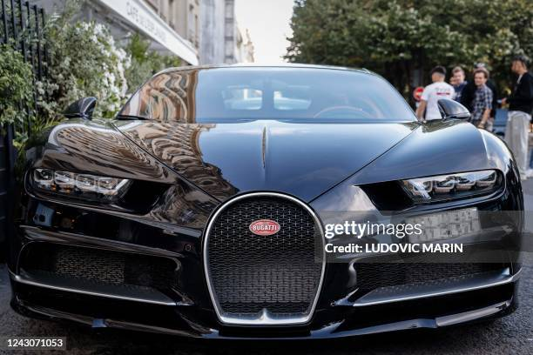

Article;;0025678

Talk;;about sport cars

Read;;Hifazaterasool

Edit;;Hifazaterasool

View history

we can see that which car is best fore driving :
If we see sport cars then I offer sport cars of different companies like (FRARY)

FRARY

Appearance
hide
From Wikipedia, the free encyclopedia
This article is about roadgoing cars. For racing cars, see Sports car racing. For the album by Judie Tzuke, ee Sports Car (album). For the song by Tate McRae, see Sports Car (song).
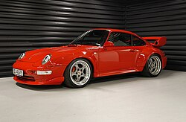1996 Porsche 911 GT2, a model homologated for sports car racing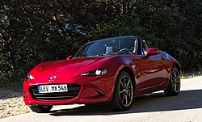Mazda MX-5, one of the world's best-selling sports cars^{[1][2]}
A sports car is a type of automobile that is designed with an emphasis on dynamic performance, such as handling, acceleration, top speed, the thrill of driving, and racing capability. Sports cars originated in Europe in the early 1910s and are currently produced by many manufacturers around the world.
Definition
Definitions of sports cars often relate to how the car design is optimised for dynamic performance,^{[3][4]} without any specific minimum requirements; both a Triumph Spitfire and Ferrari 488 Pista can be considered sports cars, despite vastly different levels of performance. Broader definitions of sports cars include cars "in which performance takes precedence over carrying capacity",^{[5]} or that emphasise the "thrill of driving"^{[6]} or are marketed "using the excitement of speed and the glamour of the (race)track"^{[7]} However, other people have more specific definitions, such as "must be a two-seater or a 2+2 seater"^{[8]} or a car with two seats only.^{[9][10]}
In the United Kingdom, early recorded usage of the "sports car" was in The Times newspaper in 1919.^{[11]} The first known use of the term in the United States was in 1928.^{[9]} Sports cars started to become popular during the 1920s.^{[12]} The term initially described two-seat roadsters (cars without a fixed roof), however, since the 1970s the term has also been used for cars with a fixed roof (which were previously considered grand tourers).^{[13]}
Attributing the definition of 'sports car' to any particular model can be controversial or the subject of debate among enthusiasts.^{[14][15][13]} Authors and experts have often contributed their ideas to capture a definition.^{[16][17][18][19]} Insurance companies have also attempted to use mathematical formulae to categorise sports cars, often charging more for insurance due to the inherent risk of performance driving.^{[20][21]}
There is no fixed distinction between sports cars and other categories of performance cars, such as muscle cars and grand tourers, with some cars being members of several categories.^{[22][23][24][25][26]}
Common characteristics
Seating layout
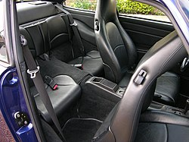2+2 layout (Porsche 911)
Traditionally, the most common layout for sports cars was a roadster (a two-seat car without a fixed roof).^{[27]} However, there are also several examples of early sports cars with four seats.^{[5]}
Sports cars are not usually intended to transport more than two adult occupants regularly, so most modern sports cars are generally two-seat or 2+2 layout (two smaller rear seats for children or occasional adult use). Larger cars with more spacious rear-seat accommodation are usually considered sports sedans rather than sports cars.
The 1993–1998 McLaren F1 is notable for using a three-seat layout, where the front row consists of a centrally located driver's seat.

Engine and drivetrain layout
The location of the engine and driven wheels significantly influence the handling characteristics of a car and are therefore crucial in the design of a sports car.^{[28][29][30][31][32]} Traditionally, most sports cars have used rear-wheel drive with the engine either located at the front (FR layout) or in the middle of the vehicle (MR layout). Examples of FR layout sports cars include the Caterham 7, Mazda MX-5, and the Dodge Viper. Examples of MR layout sports cars are the Ferrari 488, Ford GT, and Toyota MR2.^{[33]} To avoid a front-heavy weight distribution, many FR layout sports cars are designed so that the engine is located further back in the engine bay, as close to the firewall as possible.^{[34][35][36]}
Since the 1990s, all-wheel drive has become more common in sports cars. All-wheel drive offers better acceleration and favorable handling characteristics (especially in slippery conditions), but is often heavier and more mechanically complex than traditional layouts.^{[37]} Examples of all-wheel drive sports cars are the Lamborghini Huracan, Bugatti Veyron, and Nissan GT-R.^{[38][39]}
Rear engine layouts are not typical for sports cars, with the notable exception of the Porsche 911.^{[40]}
The front-wheel drive layout with the engine at the front (FF layout) is generally the most common for cars, but it is not as common among traditional sports cars. Nonetheless, the FF layout is used by sport compacts and hot hatches such as the Mazdaspeed3. Sports cars with an FF layout include the Fiat Barchetta, Saab Sonett, and Opel Tigra.^{[41][42][43][44]}

Europe

1895–1917: Brass Era of cars
The ancestor of all high-performance cars had its origin in Germany. The 28-h.p. Cannstatt-Daimler racing car of 1899 was without a doubt the first attempt to give real performance to a road car. Many of its features, such as a honeycomb radiator and gate gear change, were continued on the much improved version which Paul Daimler designed in 1899-1900. This was of course the famous Mercedes. It also laid down standards of chassis design which were to be followed, almost unthinkingly, for the next thirty years. Several variants of the car appeared during the next year or two, all conforming to the same basic design and earning for themselves a reputation second to none for fast and reliable travel. The 60-h.p. cars were announced late in 1902. The cars were possessed of a very real performance superior to anything else which could be bought at the time... and the model achieved an almost invincible position among the fast cars of its day.
The Sports Car: Development and Design^{[45]}
The basis for the sports car is traced to the early 20th century touring cars and roadsters, and the term 'sports car' would not be coined until after World War One.^{[9][46]}
A car considered to be "a sports-car years ahead of its time" is the 1903 Mercedes Simplex 60 hp,^{[47]} described at the time as a fast touring car and designed by Wilhelm Maybach and Paul Daimler. The Mercedes included pioneering features such as a pressed-steel chassis, a gated 4-speed transmission, pushrod-actuated overhead inlet valves, a honeycomb radiator, low-tension magneto ignition, a long wheelbase, a low center of mass and a very effective suspension system.^{[48]} The overall result was a "safe and well-balanced machine" with a higher performance than any other contemporary production car.^{[45][49][50]} At the 1903 Gordon Bennett Cup, a production Simplex 60 hp was entered only due to a specially built 90 hp racing car being destroyed in a fire; the 60 hp famously went on to win the race.^{[51]}
The 1910 Austro-Daimler 27/80 is another early sports car which had success in motor racing.^{[52]} The 27/80 was designed by Ferdinand Porsche, who drove the car to victory in the 1910 Prince Henry Tour motor race.^{[53]} The Vauxhall and Austro-Daimler —like the Mercedes Simplex 60 hp— were production fast touring cars.^{[50]} The 1912 Hispano-Suiza Alfonso XIII is also considered one of the earliest sports cars, as it was a "purpose built, high performance, two-seater production automobile".^{[54]} The model was named after King Alfonso XIII of Spain, a patron of the car's chief designer and an enthusiast for the marque.^{[54][55]} Other early sports cars include the 1905 Isotta Fraschini Tipo D, the 1906 Rolls-Royce Silver Ghost, the 1908 Delage,^{[citation needed]} the 1910 Bugatti Type 13,^{[45][49][56]} and the 1912 DFP 12/15.^{[49]}
Early motor racing events included the 1903 Paris–Madrid race, the 1905–1907 Herkomer Trophy,^{[57]} the 1908–1911 Prince Henry Tour and the 1911–present Monte Carlo Rally.^{[52]} The Prince Henry Tours (which were similar to modern car rallies) were among the sporting events of the period, bringing renown to successful entrants. The Prince Henry Tours started the evolution of reasonably large and technically advanced production sports cars.^{[45][49]}
In England, the development of sporting cars was inhibited by the Motor Car Act 1903, which imposed a speed limit of 20 mph (32 km/h) on all public roads. This led to the 1907 opening of the Brooklands motor circuit, which inspired the development of performance cars such as the 1910 Vauxhall Prince Henry, 1910 Sunbeam 12/16,^{[58]} 1910 Talbot 25 hp, 1910 Straker-Squire 15 hp and 1913 Star 15.9 hp.^{[45][59]}
- 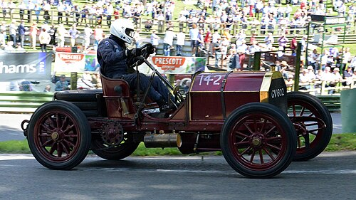
Mercedes Simplex 60 hp (1903)

- 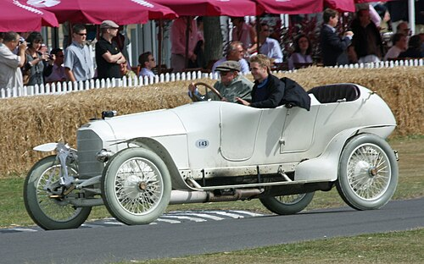
Austro-Daimler Prince Henry (1910-1914)

- 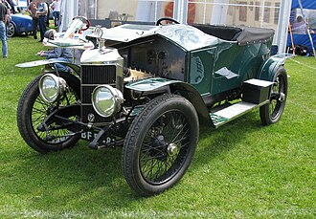
Vauxhall Prince Henry (1912)

- 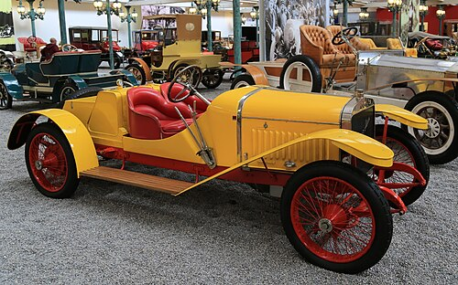
Hispano-Suiza Alfonso XIII (1912)

- 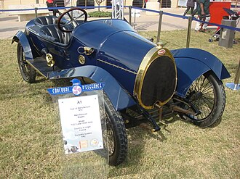
Bugatti Type 22 (1913)

- 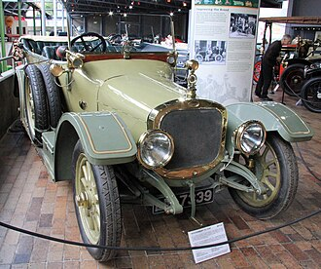
Sunbeam 12/16 (1914)
1919–1929: Vintage Era cars
Following the halt in sports car production caused by World War I, Europe returned to manufacturing automobiles from around 1920. It was around this time that the term 'Sports Car' began to appear in the motor catalogues, although the exact origin of the name is not known. The decade that followed became known as the vintage era and featured rapid technical advances over the preceding Brass Era cars.^{[60][61]} Engine performance benefited from the abandonment of "tax horsepower" (where vehicles were taxed based on bore and number of cylinders, rather than actual power output)^{[62]} and the introduction of leaded fuel, which increased power by allowing for higher compression ratios.
In the early 1920s, the cost to produce a racing car was not significantly higher than a road car, therefore several manufacturers used the design from the current year's racing car for the next year's sports car.^{[46]} For example, the 1921 Ballot 2LS based on the racing car that finished third at the 1921 French Grand Prix.^{[63]} The Benz 28/95PS was also a successful racing car, with victories including the 1921 Coppa Florio.^{[52]} Another approach— such as that used by Morris Garages— was to convert touring cars into sports cars.^{[46][64]}
The first 24 Hours of Le Mans race for sports cars was held in 1923,^{[46]} although the two-seat sports cars only competed in the smallest class, with the majority of cars entered being four-seat fast touring cars.^{[65]} "This race, together with the Tourist Trophy Series of Races, organised after the first World War by the R.A.C., appealed to the public imagination and offered to the manufacturers of the more sporting cars an excellent opportunity for boosting sales of their products."^{[46]} The classic Italian road races— the Targa Florio, and the Mille Miglia (first held in 1927)— also captured the public's imagination.^{[46]}
By 1925, the higher profits available for four-seater cars resulted in the production of two-seat sports cars being limited to smaller manufacturers such as Aston-Martin (350 Astons built from 1921 to 1939) and Frazer-Nash (323 cars built from 1924 to 1939).^{[52]} Then by the late 1920s, the cost of producing racing cars (especially Grand Prix cars) escalated, causing more manufacturers to produce cars for the growing sports car market instead.
Significant manufacturers^{[citation needed]} of sports cars in the late 1920s were AC Cars, Alfa Romeo, Alvis, Amilcar, Bignan and Samson, Chenard-Walcker, Delage, Hispano-Suiza, Hotchkiss, Mercedes-Benz and Nazzaro.^{[52]} Two cars from the Vintage Era that would influence sports cars for many years were the Austin Seven and MG M-type "Midget".^{[60][61]} Successful sports cars from Bentley during this era were the Bentley 3 Litre (1921–1929) and the Bentley Speed Six (1928–1930), with the former famously described by Bugatti's founder as "the fastest lorry in the world".
- 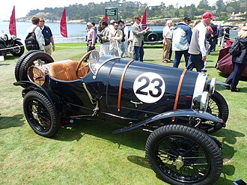
Bugatti Type 13 Brescia (1920)

- 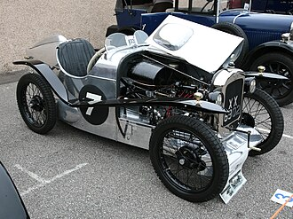
Austin 7 Brooklands (1927)

- 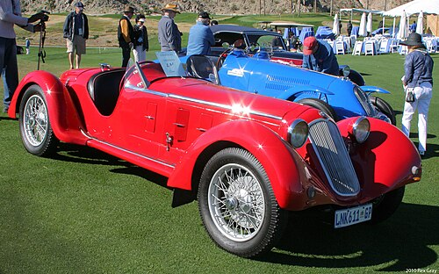
Alfa Romeo 6C (1929)

- 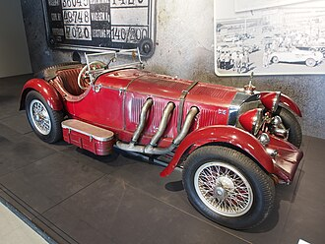
Mercedes-Benz SSK (1929)

- 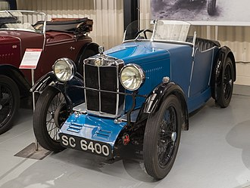
MG M-type Midget (1930)
1930–1939: Pre-war Era cars
Between the Great Depression and the World War II the pre-war era was a period of decline in importance for sports car manufacturers,^{[66][46]} although the period was not devoid of advances,^{[62]} for example streamlining.^{[67]} Cheap, light-weight family sedans with independent front suspension— such as the BMW 303, Citroën Traction Avant and Fiat 508— offered similar handling and comfort to the more expensive sports cars. Powerful, reliable, and economical (although softly suspended) American saloons began to be imported to Europe in significant numbers.^{[citation needed]} Sports car ownership was increased through models such as the Austin 7 and Wolseley Hornet six, however many of these sports cars did not offer any performance upgrades over the mass-produced cars upon which they were based.^{[62]}
The highest selling sports car company of the 1930s was Morris Garages,^{[62]} who produced 'MG Midget' models of the M-Type, J-Type, P-Type and T-Type. The K3 version of the K-Type Magnette was a successful racing car, achieving success in the Mille Miglia, Tourist Trophy and 24 Hours of Le Mans.^{[62][68]}
The Bugatti Type 57 (1934-1940) was another significant sports car of the pre-war era and is now among the most valuable cars in the world.^{[69][70]} The T57 was successful in sports car races, including winning the 1937 24 Hours of Le Mans^{[71]} and 1939 24 Hours of Le Mans.^{[72]} Another successful Bugatti sports car was the Bugatti Type 55 (1932-1935), which was based on the Type 51 Grand Prix racing car.
- 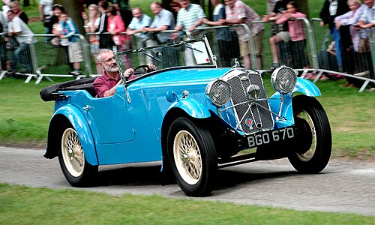
Wolseley Hornet (1930-1936)

- 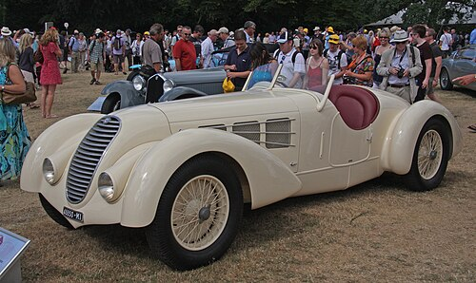
Alfa Romeo 8C (1931-1939)

- 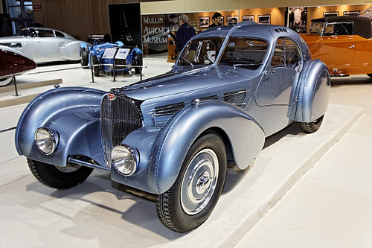
Bugatti Type 57 (1934-1940)

- 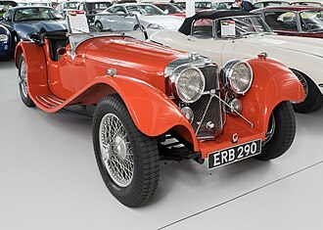
SS Jaguar 100 (1936-1939)

- 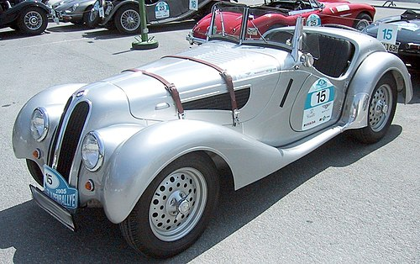
BMW 328 (1936-1940)
1939–1959: Growth following World War II
The decade following the Second World War saw an "immense growth of interest in the sports car, but also the most important and diverse technical developments [and] very rapid and genuine improvement in the qualities of every modern production car; assisted by new design and manufacturing techniques a consistently higher level of handling properties has been achieved."^{[73]}
In Italy, a small but wealthy market segment allowed for the manufacture of a limited number of high-performance models directly allied to contemporary Grand Prix machines,^{[73]} such as the 1948 Ferrari 166 S.^{[citation needed]} A new concept altogether was the modern Gran Turismo class from Italy, which was in effect unknown before the war: sustained high-speed motoring from relatively modest engine size and compact closed or berlinetta coachwork.^{[73]} The 1947 Maserati A6 1500 two-seat berlinetta was the first production model from Maserati.
In Germany, the motor industry was devastated by the war, but a small number of manufacturers returned it to prominence. In 1948, the Porsche 356 was released as the debut model from Porsche.^{[74]} The significance of the Porsche 356 and its successors was described in 1957 as "future historians must see them as among the most important of mid-century production cars".^{[73][75][76]} The 1954 Mercedes-Benz 300 SL is another significant car from this era.^{[73]}
- 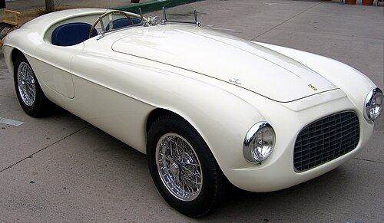
Ferrari 166 Inter Barchetta (1948-1953)

- 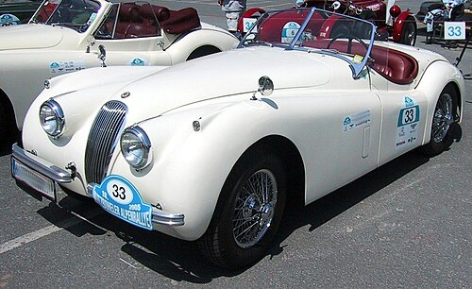
Jaguar XK120 Roadster (1948-1954)

- 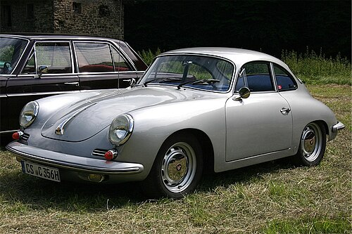
Porsche 356 (1948-1965)

- 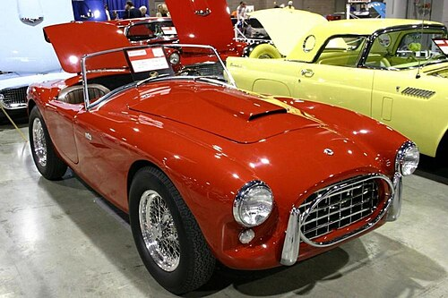
AC Ace (1953-1963)

- 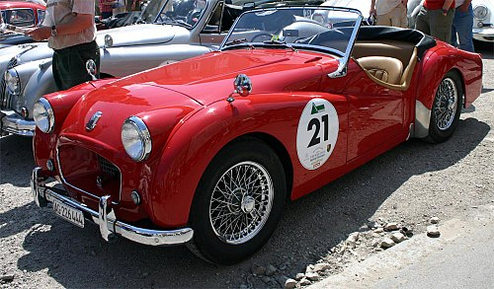
Triumph TR2 (1953-1955)

- 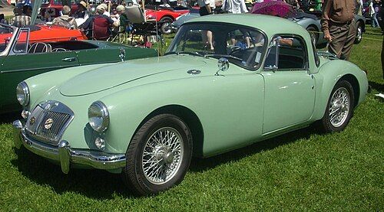
MG MGA (1955-1959)

- 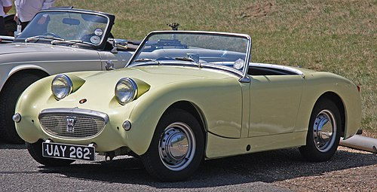
Austin-Healey Sprite (1958-1961)
1960–1979: Lightweight roadsters, mid-engined supercars
The 1961 Jaguar E-Type is an iconic sports car of the early 1960s, due to its attractive styling and claimed top speed of 241 km/h (150 mph). The E-type was produced for 14 years and was initially powered by a six-cylinder engine, followed by a V12 engine for the final generation.
In 1962, the MG B introduced a new era of affordable lightweight four-cylinder roadsters. The MG B used a unibody construction and was produced until 1980. Other successful lightweight roadsters include the Triumph Spitfire (1962-1980) and the Alfa Romeo Spider (1966-1993). The Fiat X1/9 (1972-1989) was unusual for its use of a mid-engine design in an affordable roadster model. A late entrant to the affordable roadster market was the 1975 Triumph TR7, however by the late 1970s the demand for this style of car was in decline, resulting in production ceasing in 1982.
The original Lotus Elan (1962-1975) two-seat coupe and roadster models are an early commercial success for the philosophy of achieving performance through minimizing weight and has been rated as one of the top 10 sports cars of the 1960s. The Elan featured fibreglass bodies, a backbone chassis, and overhead camshaft engines.
A different style of roadster was the AC Cobra, released in 1962, which was fitted with V8 engines up to 7.0 L (427 cu in) in size by Shelby.
The Porsche 911 was released in 1964 and has remained in production since. The 911 is notable for its use of the uncommon rear-engine design and the use of a flat-six engine. Another successful rear-engine sports car was the original Alpine A110 (1961-1977), which was a successful rally car during the Group 4 era.
In 1965, the BMW New Class Coupes were released, leading to the BMW 6 Series which remains in production to this day.
The Lamborghini Miura (1966) and Alfa Romeo 33 Stradale (1967) mid-engined high-performance cars are often cited as the first supercars.^{[77][78][79]} Other significant European models of the 1960s and 1970s which might be considered supercars today are the Ferrari 250 GTO (1962-1964), Ferrari 250 GT Lusso (1963-1964), Ferrari 275 GTB/4 (1966-1968), Maserati Ghibli (1967-1973), Ferrari Daytona (1968-1973), Dino 246 (1969-1974), De Tomaso Pantera (1971-1993), Ferrari 308 GTB (1975-1980) and BMW M1 (1978-1981).
In 1966, the Jensen FF became the first sports car to use

